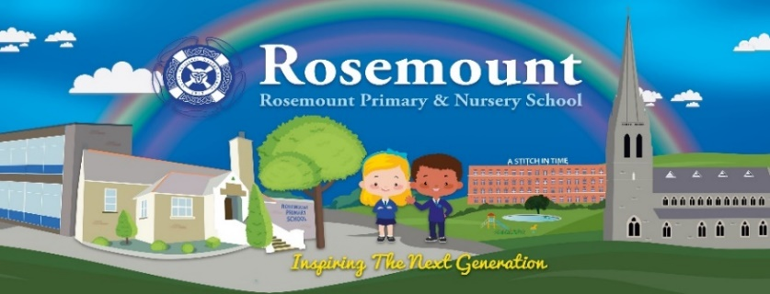

Dear Parent/Guardian,

We are delighted that you have chosen Rosemount Primary and Nursery school for your child’s education and we are all looking forward to getting to know you and your child. Due to COVID -19 restrictions we are unable to invite you into the school building for an Induction Programme. Instead we aim to share this information through our school website www.rosemountps.com You can access our ‘Welcome to Primary 1’ power point on the website. It contains lots of useful information that will help you and your child with their transition to Primary School. Click on Primary 1 Induction Area in the “Latest News and Events Section” of the website.
The following documents will be found:
- EA link to transport/Free school meals application forms
- Primary One Teacher Induction PowerPoint
- Getting Ready to Learn Leaflet
- All About Me Booklet
- Being a good friend cards

Your child’s class teacher will be_________________________________________
In Rosemount Primary School and Nursery Unit’s most recent inspection, we were delighted to achieve the outcome of outstanding.
Selecting a school is a very important decision and we fully appreciate the trust you place in us. By working in close partnership with you, we will ensure that your child thrives at Rosemount Primary School in all areas. We are committed to providing the fullest of opportunities for all pupils and we aim to allow everyone to develop their full potential in a secure and safe environment. We look forward to beginning our journey together through the next 7 years.
Yours sincerely,
Caroline Burton and Gemma Coyle Paul Bradley
(Primary 1 teachers) (Principal )

